Sl. No. | Component |  | Quantity
1 | Arduino Uno Board with cable | 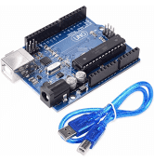 | 01
2 | I2C LCD (Serial LCD) | 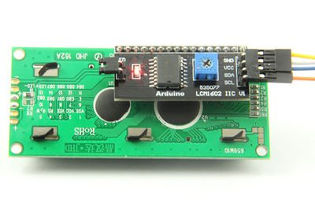 | 01
3 | Potentiometer (1k ohm) and (10k ohm) | 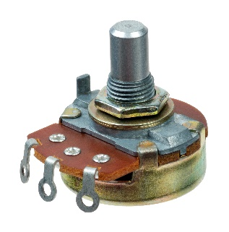 | 02 each
4 | Voltage sensor | 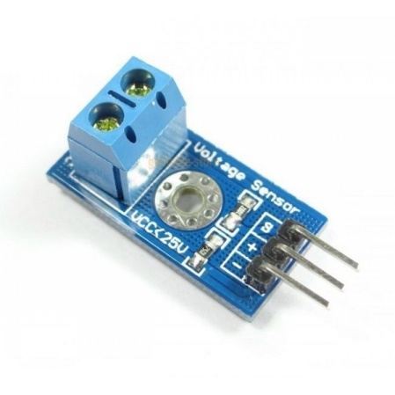 | 01
6 | A3180 Optocoupler | 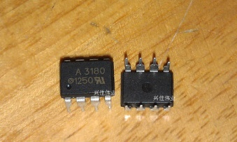 | 02
 | 6N135  Optocoupler |  | 02
8 | MOSFET (IPW60R041C6) | 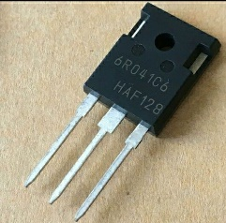 | 02
9 | Power Diode (APT60DQ60BCT(G)) | 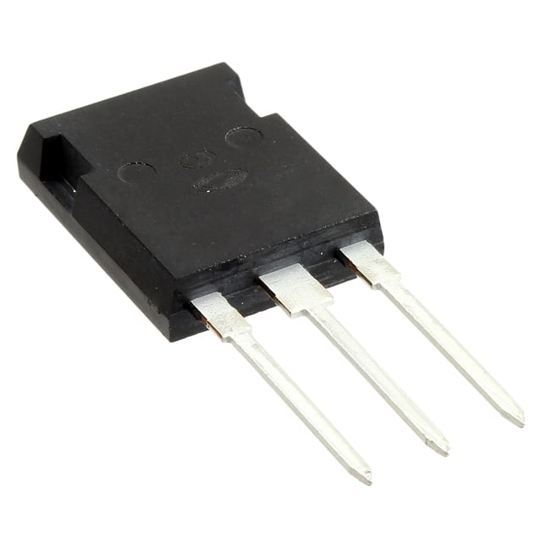 | 02
13 | Resistors | 300 ohm/300 Watt | 01
 |  | 100 ohm/5 Watt | 01
 |  | 47K ohm/Half Watt | 10
 |  | 1K ohm/Quarter Watt | 10
 |  | 100 ohm/Half Watt | 10
 |  | 200 ohm/Half Watt | 10
 |  | 100 ohm/5 Watt | 02
 |  | 10 ohm / Half watt | 05
 |  | 1.2 kohm/Half watt | 05
 |  | 1 kohm/Half watt | 05
 |  | 10 kohm/Half watt | 05
14 | Inductor | 115 mH @2A, @20kHz  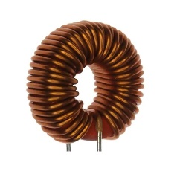 | 01
15 | Capacitor | 470 Micro Farad / 100V (Electrolytic)  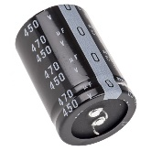 | 01
 |  | 0.00416 Micro Farad / 400V (Electrolytic) | 01
 |  | 22 Micro Farad/25V (Electrolytic) | 02
 |  | 100 nano Farad (Ceramic) | 02
 |  | - Micro Farad (Ceramic)  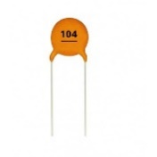 | 05
 |  | - micro Farad/400V (axial lead yellow color) 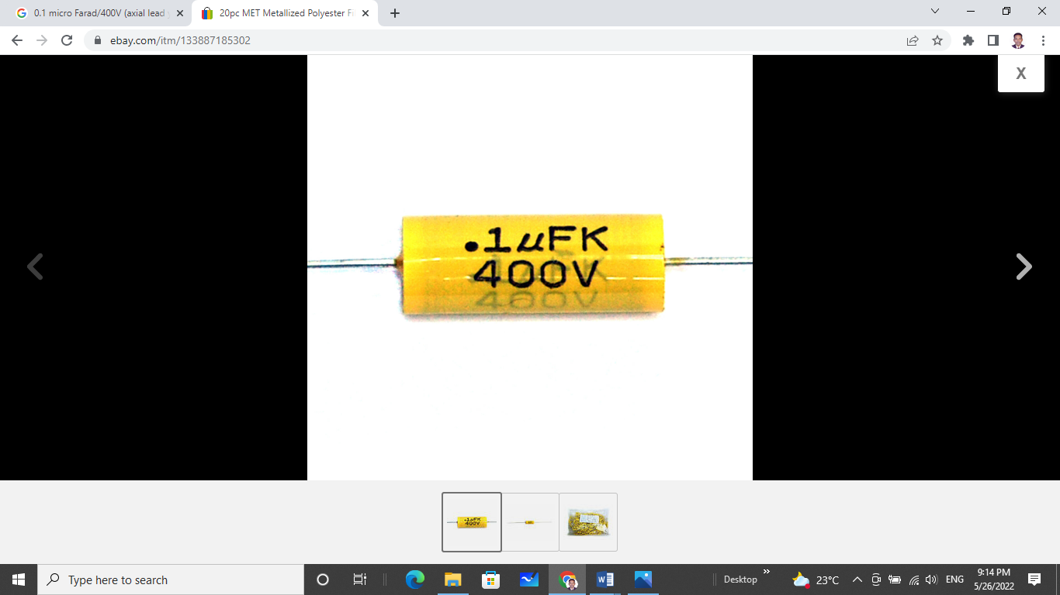 | 01
16 | Connecting wires (Male to Male, Male to Female, Female to Female) | 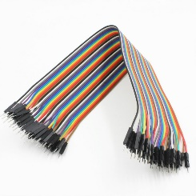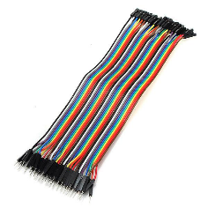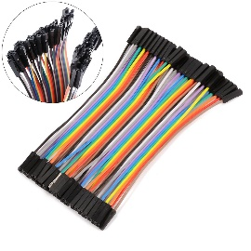
18 | Bread Boards | 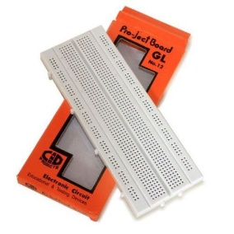 | 01
19 | Tag Board | 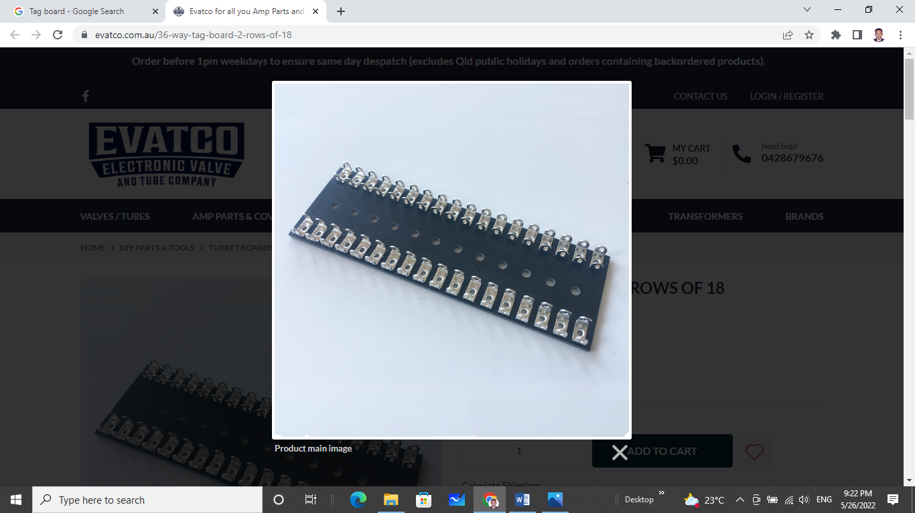 | 01
20 | 7805 IC | 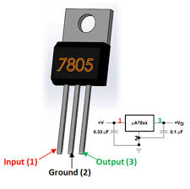 | 02

